School: Van To Primary school  Full name: ……………………………..  Class 4 …… | THE FIRST SEMESTER TEST  ENGLISH – GRADE 4  SCHOOL YEAR: 2022 - 2023  Time: 40 minutes

SKILL | LISTENING | READING | WRITING | SPEAKING | TOTAL
MARK

PART I: LISTENING

Question 1. Listen and tick ✓. There is one example (0) (1 pt)

- A | B
- A | B
- A | B 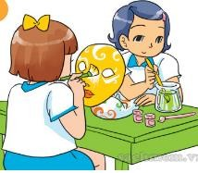
- A | B
- A | B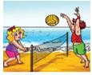

Question 2. Listen and number. (1 pt)

 | 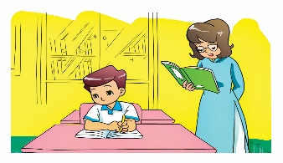 | 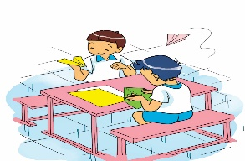
A | B | C | D
Question 3. Listen and circle the correct answers (1 pt). There is one example (0) (1 pt)
- a. at home
on the beach
b.
c. at the zoo

- a. On Mondays and Wednesdays
  - On Tuesdays and Thursdays
  - On Tuesdays and Friday

- a. Watching TV
  - Listening to music
  - Cooking
- a. They’re playing volleyball
  - They’re playing football
  - They’re playing table tennis

- a. IT, Art and Music
  - IT, Art and Maths
  - IT, Art and Science
Question 4. Listen and write. There is one example (0) (1pt)

- Linda:Good night, Mom 3. What day is it today?
Mom: Good night, Linda It’s

- What nationality are you? I’m
4. When’s your birthday?
It’s on the first of

- I was at the

PART II. READING AND WRITING

Question 5. Look and read. Write Yes or No (1pt).

 | A. Kim can skip. | Yes
 | B. He likes riding a bike | No
 | 1.I like playing chess
 | 2.Today is Tuesday
 | 3.I’m from Vietnam
 | 3.It’s on the first of October

Question 6. Look and write. There is one example (1 pt)

Science
Monday
Tuesday
Wednesday
Today is (0) Monday. I have (1)……………….
today.
Tomorrow is (2) I don’t have
Science on (3) I have Science on
(4) too.

Question 7. Read and write one word in each gap ( 1pt)

Hi. My name’s Phong. I’m from Viet Nam. I’m Vietnamese. I’m a pupil at Le Hong Phong Primary school. It’s in Bat Trang village. I’m in class 4D. I go to school from Monday to Friday. I have Maths, Vietnamese, Music, PE, IT, English and Science. My favourite subject is Vietnamese.
0. Phong is from Vietnam

1. His school is in Bat Trang.......................................................

2. He’s in class..............................................................................

3. He goes to school from Monday to...........................................

4. His favourite subject is...............................................................

Question 8. Fill in each gap with a suitable word from the box (1 pt)

June | America | football | Science Monday | kite

Paul is my new classmate. He’s from (0) America. His birthday is on the second of

  - ……………………….. . He likes playing (2) and flying a

- …………………. His favourite subject is (4)……………………….

PART IV. SPEAKING (2pt)

  - Listen and repeat
  - Point, ask and answer
  - Let's talk (Role play)

The end!

KEY
PART I: LISTENING

Question 1: listen and tick
1: A, 2: B, 3: A, 4: B
Question 2: listen and number
D: 1, B: 2, A: 3, C; 4
Question 3: Listen and circle
1: b, 2: c, 3: a, 4: c
Question 4: listen and write
1: Vietnamese, 2: Monday, 3: Steptember, 4: zoo

PART II: READING AND WRITING

Question 5: Look and read. Write Yes or No.
1: Yes, 2: No, 3: No, 4: Yes
Question 6: Look and write
1: Science, 2: Tuesday, 3: Tuesday, 4: Wednesday
Question 7: Read and write one word in each gap
1: village, 2: 4D, 3: Friday, 4: Vietnamese
Question 8: Fill in each gap with a suitable word from the box
1: June, 2: football, 3: kite, 4: Science

I was at the

