School: Van To Primary school  Full name: ……………………………..  Class 3 …… | THE FIRST SEMESTER TEST  ENGLISH – GRADE 3  SCHOOL YEAR: 2022 - 2023  Time: 40 minutes

MARK | Listening |  |  |  | Reading and writing |  |  |  | Speaking | Total
 | Q1 | Q2 | Q3 | Q4 | Q5 | Q6 | Q7 | Q8 | Q9
- LISTENING
Question 1: Listen and tick. There is one example.
0. A. | B.
1. A. 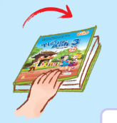 | B. 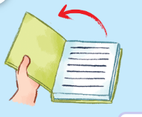
2. A. 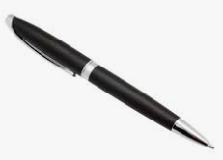 | B.
3. A. | B.
4. A. | B. 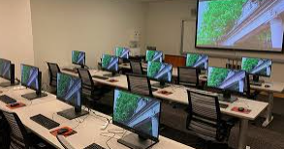

Question 2: Listen and circle. There is one example.
- A. The pencil is blue.
B. It is brown.
1. A. I have a book.
B. Does she have an eraser?
2. A. I’m Mary.
B. My name’s Nam.
3. A. Let’s go to the playground.
B. Is your classroom big?
4. A. Speak English, please.
B. May I stand up?
Question 3: Listen and number. There is one example.
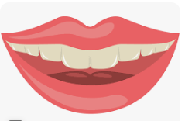  0 | 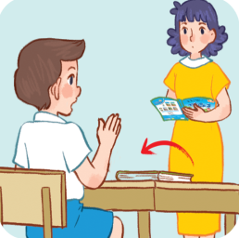  A. | 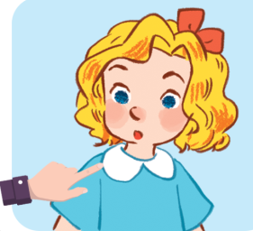  B. | 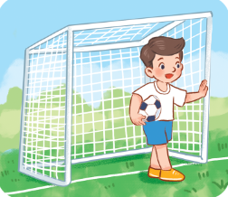  C. | 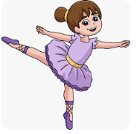  D.

Question 4: Listen and complete. There is one example.

0. What’s your name? - My name’s Huong.

1. A: What’s your hobby?

B: It’s………………………..

2. Let’s go to the ………………...

3. The pencils are………….......

4. A: What do you do at break time?

B: I play…………………..
B.READING AND WRING:
Question 5: Read and tick.
- Do you have an eraser? - Yes, I do.
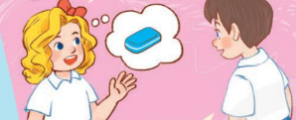

- A: What’s your hobby?
B: It’s painting.

2. A: What do you do at break time?
B: I play volleyball at break time.
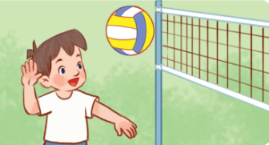

- . A: May I come in?
B: Yes, you can.
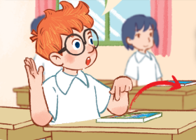 | 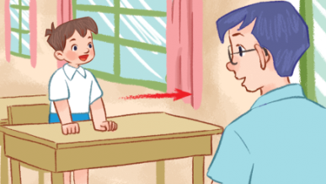 | 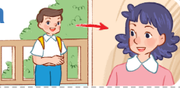
4. It’s a hand.
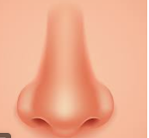

Question 6 : Read and match. There is one example
0. That’s Mr Long. |  | A.
- Touch your face! |  | B. 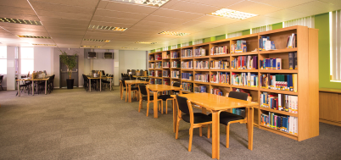
- A: Let’s go to the playground.  B: OK, let’s go |  | C. 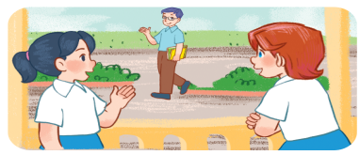
3. The pencil case is white. |  | D.
4. A: Is that our library?  B: Yes, it is |  | E.
Question 7: Read and complete
eraser have my pen
Look at my school things. I (1)………………. a notebook, a (2) ……………, a pencil case, an (3) …………….and an English book. I like (4) ……………… school things.
Do you have any school things?
Question 8: Reorder the word to make correct sentence. There is one example.

0. Huong / My / is/ name.
=> My name is Huong.
1. eye. /is / an / It/
=> ……………………………………….………………………………
2. ruler? / What / the / is / colour /
=> ……………………………………….………………………………
3. badminton / at / I / break time. / play/
=> ……………………………………….………………………………
4. nine / years / I/ old. / am
=> ……………………………………….……………………………….
5. close / May / the / I / book? /
=> ……………………………………….……………………………….

C.SPEAKING: PART 1: Interview : Teacher asks 3 questions/ 1 student.
Example:
1. What’s your name?  2. How old are you?  3. What’s this?  4. What’s your hobby? | 5. What do you do at break time?  6. Do you have a pencil/ a pencil case/ a notebook…?  7. What colour is your schoolbag/ ruler/ pen…?

PART 2: Look, point and say Teacher shows 2 flashcards/1 question. Student listens to the teacher, points to the flashcard and says.
Example:
Flashcard 1 | Flashcard 2
 | 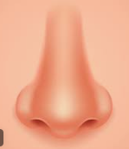
Teacher: Open your……!
- Student points to flashcard 1 and says: Open your eyes!
Flashcard 1 | Flashcard 2
Teacher: Let’s go ….…….
- Student points to flashcard 1 and says: Let’s go to the playground.

PART 3: Let’s talk (0,5)
Teacher shows one picture and cues. Student uses the cues to talk about the picture.

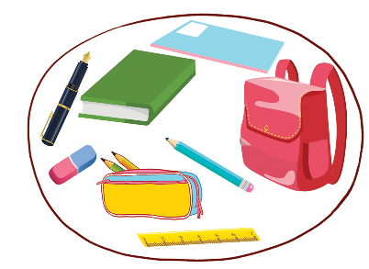 | Example:  1. Look/ school things.  I / pen, book, ruler, eraser….  2. I like / draw. Let’s draw a picture.
The end!

KEYS ENGLISH 3
- LISTENING ( 4pts)
Question 1: Listen and tick Mỗi câu đúng 0,25 điểm (0,25x4)
1 Female teacher: Open your book, please!
2. Female teacher: Do you have a pen?
Mai: Yes, I do.
3. Male teacher: What do you do at break time?
Nam: I play basketball.
4. Minh: Is that your computer room?
Mary: Yes, it is.
Answers: | 0.B | - B | - A | - B | - B

Question 2: Listen and circle. Mỗi câu đúng 0,25 điểm (0,25x4)
1 Does she have an eraser?
2 I’m Mary.
3 Is your classroom big?
- Speak English, please.

Answers: | 0.B | 1. B | 2. A | 3. B | 4. A

Question 3: Listen and number. Mỗi câu đúng 0,25 điểm (0,25x4)
1. A: Is this Mary?
B: Yes, it is.
2. A: What’s your hobby?
B: Dancing.
3. A: May I open the book?
B: Yes, you can.
4. A: What do you do at break time?
B: I play football.
Answers: | 0.0 | 1.B | 2.D | 3.A | 4.C
Question 4: Listen and complete. There is one example. (1 pt)
Mỗi câu đúng 0,25 điểm (0,25x4)

1. A: What’s your hobby?

B: It’s singing.

2. Let’s go to the classroom.

3. The pencils are blue.

4. A: What do you do at break time?
B: I play football
Answers: | 0. | 1. singing | 2.classroom | 3. blue | 4. football

B.READING AND WRING (4pts)
Question 5: Read and tick. Mỗi câu đúng 0,25 điểm (0,25x4)
Answers: | 0. B | 1. A | 2.A | 3. C | 4. B

Question 6 : Read and match. Mỗi câu đúng 0,25 điểm (0,25x4)
Answers: | 0. C | 1. A | 2.D | 3. E | 4. B

Question 7: Read and complete. Mỗi câu đúng 0,25 điểm (0,25x4)
Answers: | 0. | 1. have | 2.pen | 3. eraser | 4. my

Question 8: Reorder the word to make correct sentence. There is one example.
Mỗi câu đúng 0,25 điểm (0,2x5)
- It is an eye.
- What colour is the ruler?
- I play badminton at breaktime.
- I am nine years old.
- May I close the book?

C.SPEAKING (2pts) Mỗi câu đúng 0,25 điểm

MA TRẬN ĐỀ KIỂM TRA HỌC KỲ I Môn TIẾNG Anh lỚP 3

năm hỌc: 2022 – 2023

Skills | Objectives to evaluate | Level/ point |  |  | Total
Listening |  | Level 1 | Level 2 | Level 3 | 16  4.0 pts  40%
 | Listen and tick | 4  1pt
 | Listen and circle | 4  1pt
 | Listen and number |  | 4  1pt
 | Listen and complete |  |  | 4  1pt
Reading  & Writing | Read and tick | 4  1pt |  |  | 16  2.0 pts  40%
 | Read and match | 4  1pt
 | Read and complete |  |  | 4  1pt
 | Reorder the word |  |  | 4  1pt
Speaking | Interview | 3  0,75pt |  |  | 8  2.0 pt  20%
 | Look, point and say |  | 3  0,75pt
 | Let’s talk |  |  | 2  0,5pt
Total |  | 17  42% | 13  33% | 10  25% | 40  100%

